**Project 4: TCP Fast Open**

**Hans Lau**

**CS6250 OMSCS**

In this project, we examined how TCP Fast Open improves HTTP transaction times for websites. One of the goals for this project is to replicate the results of the TCP Fast Open paper of page load times with and without TFO for webpages such as Amazon.com and Wikipedia.org.

The second goal of this project is to experiment the advantage of TFO with my own choices of websites. I fetched three websites: **canvas.gatech.edu, admission.gatech.edu, thestandard.com.hk** and ran a HTTP server (vcn4server) with the respective scripts to see the impact of TFO on PLT for different values of RTT. The results are as follows:

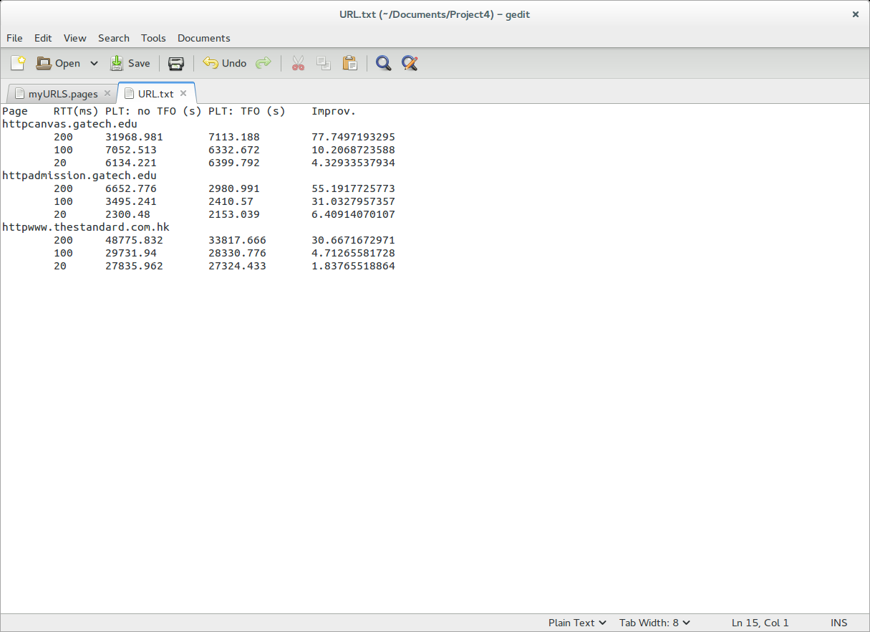

Below are graphs and analysis of the results for each website:

1. **canvas.gatech.edu**

Canvas is a learning platform website that are used by students. From the table above, it is evident that the largest PLT improvement is when RTT is 200ms and the worst performance is when RTT is 20ms. However, we can see the benefits of TFO in terms of the improvement in load times. In the graph of 20ms, we can see that for request indexes less than 5, the disabled TFO requests start after a TFO Enabled request have already ended. Similarly, that is the case for the graph of 200ms for under 15 request indexes.

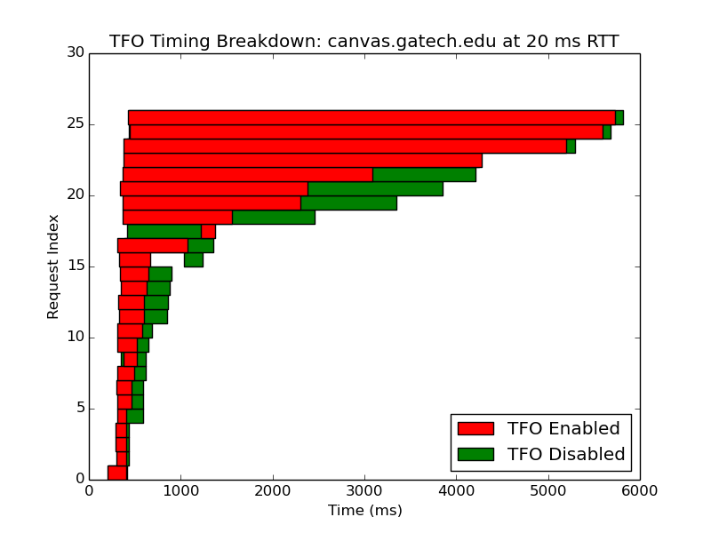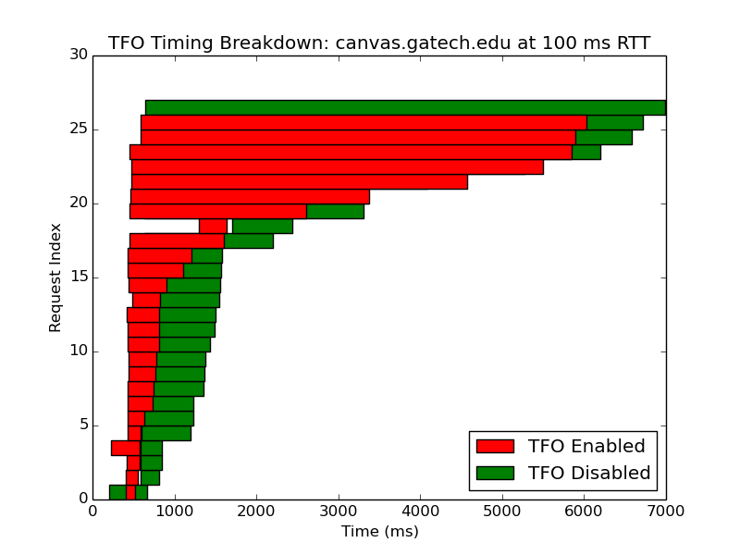

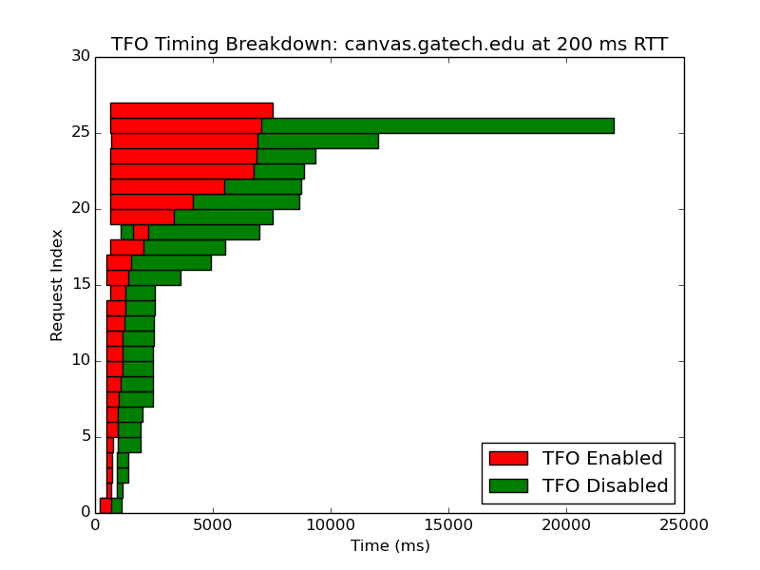

We can also see that as RTT is increased, we get a much bigger difference in speed up of load times especially for larger request indexes. If we compare the graph of RTT (20ms) vs graph of RTT (200ms), load times are less than half for TFO Enabled than for TFO Disabled for 200ms while load times are significantly larger for 20ms. This webpage contains a lot of links, pages, and learning management tools which would explain why the short RTT resulted in only slight improvements. The results here were not surprising since it aligns with what the paper has stated in that TFO still improves PLT in smaller amounts even though the webpage is heavy in content.

1. **admission.gatech.edu**

This website is the admission page for Georgia Tech. Like the previous website, we can see improvements in load times as RTT increases. I expected the improvement of 20ms to be higher than 6%; perhaps 15%. This is because the webpage only contains texts and pictures and does seem to contain much content. However, my assumption seems to be incorrect, and this webpage contain more content than I thought. With TFO enabled, it reduces latency and produces the best results with 200ms RTT and high request index. This is because non-TFO protocols aren’t suitable for handling parallel requests which results in poor performance especially when dealing with heavy content webpages.

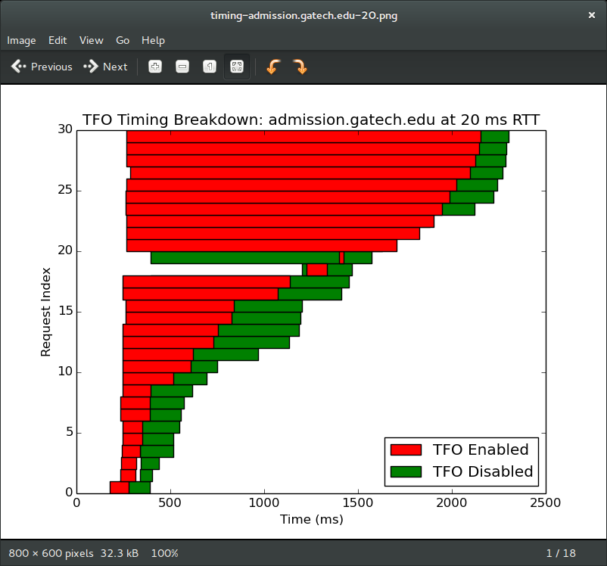 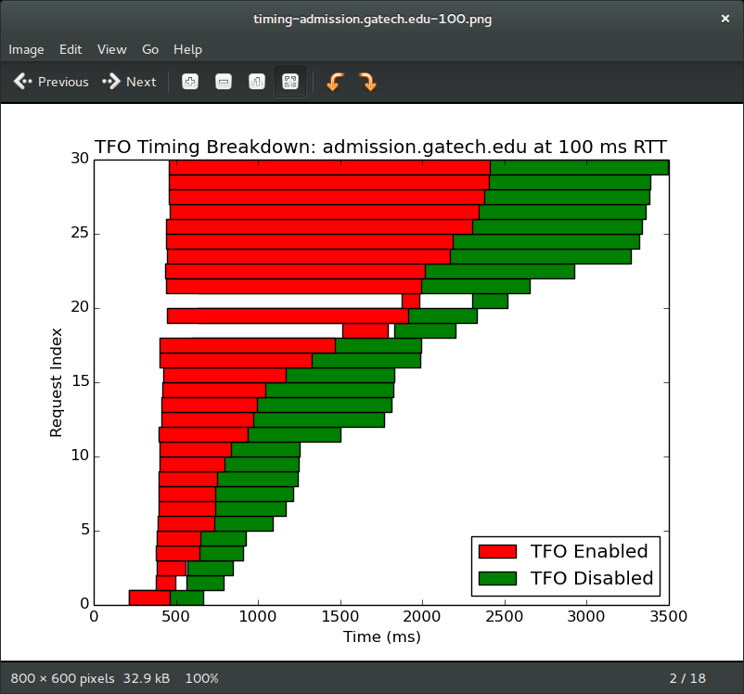



1. **thestandard.com.hk**

This webpage is a Hong Kong news channel. It contains a lot of different links to sites, content, texts, and videos and thus I expect the performance of the TFO to be like a heavy content webpage. The results for the 200ms match exactly the type of performance for heavy content webpage but for the 20ms and 100ms, it seems like TFO Enabled only performed slightly better. I would expect the improvement percentage to better 5% but it seems less than that. It could be because RTT is small and the webpage is very heavy in content, the gains from TFO are almost negligible.

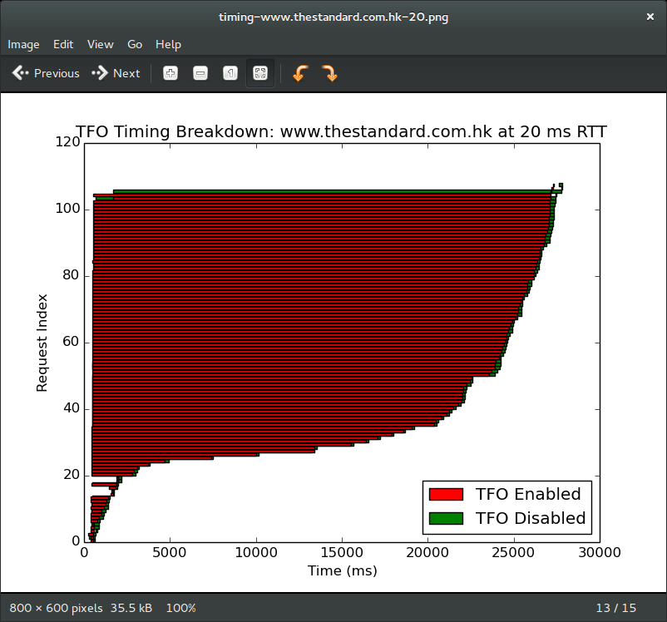 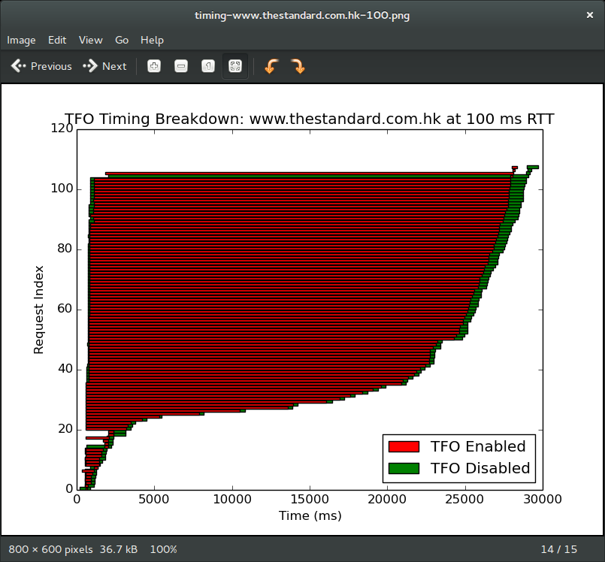

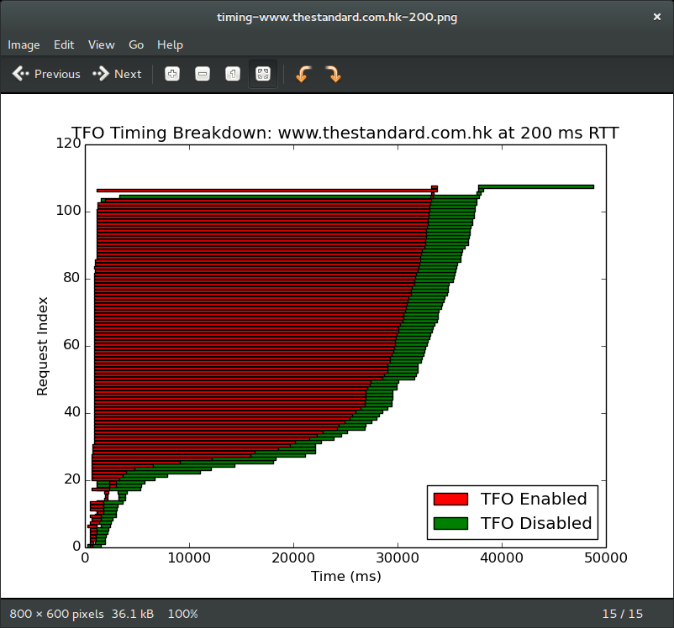

**Summary**

TFO’s cookie mechanism implemented at the TCP’s initial handshake proves to be a drastic improvement to the TCP protocol. TFO decreases latency by one RTT and the results from this project support the results and conclusion in the TFO paper. From the results, for heavy content websites, PTO improves as RTT increases but to arrive at a more accurate conclusion, more websites with different content types should be tested to reliably assess the effectivity and improvement.

**Improvements**

One improvement that could be made is to start sending data from server to client right away and then impose a security measure which prevents data transfer once a certain time period occurs without a cookie acknowledgement. There may be a risk for invaders to intercept the data transfer, but it would improve transmission and reduce latency. As mentioned in the paper, one of the things which is perhaps a weak part of TFO is the reuse of cookies where another user can use the same cookie. The paper recommends an implementation of a one time cookie to prevent this. Another method is to have a mechanism which generates a personalized cookie for addresses behind the Name Address Translation.